Cookies are more secure than just session storage or local storage.

HTTP only flag is supported on Cookies (it means JS can’t access the cookie)

If you do document.cookie it will not get cookies marked with HTTP Only.

HTTP Only cookie is created on server side only

Secure flag – if set it means it will work only for HTTPS routes

SameSite option for cookies: Lax and Strict

None – means cookie is available for everyone

If you set SameSite to **Strict**, your cookie will only be sent in a first-party context. In user terms, the cookie will only be sent if the site for the cookie matches the site currently shown in the browser's URL bar.

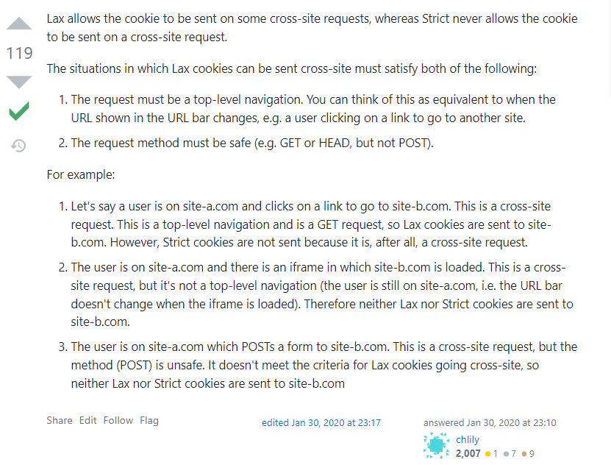

**Lax**